Google Calendar API Credentials Setup Guide
This document explains how to generate OAuth 2.0 credentials in Google Cloud Console for integrating Google Calendar API into your application.

1. Prerequisites
Before you begin, ensure you have:
- A Google account with Google Calendar enabled
- Access to Google Cloud Console (https://console.cloud.google.com/)
- A Google Cloud Project (you can create a new one if required)

2. Enable Google Calendar API
1. Go to Google Cloud Console.
2. From the top project selector, select or create a project.
3. Navigate to: Menu > APIs & Services > Library.
4. Search for 'Google Calendar API'.
5. Click 'Enable' to activate the API for your project.

3. Configure OAuth Consent Screen
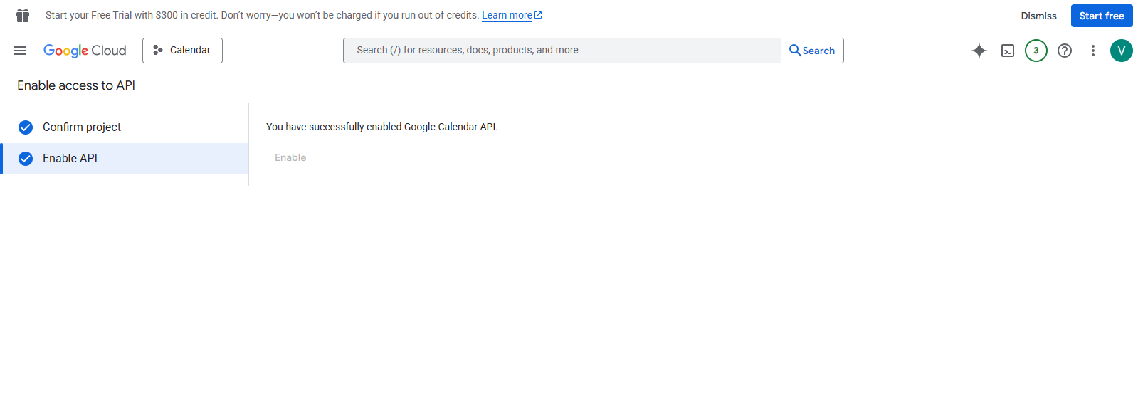
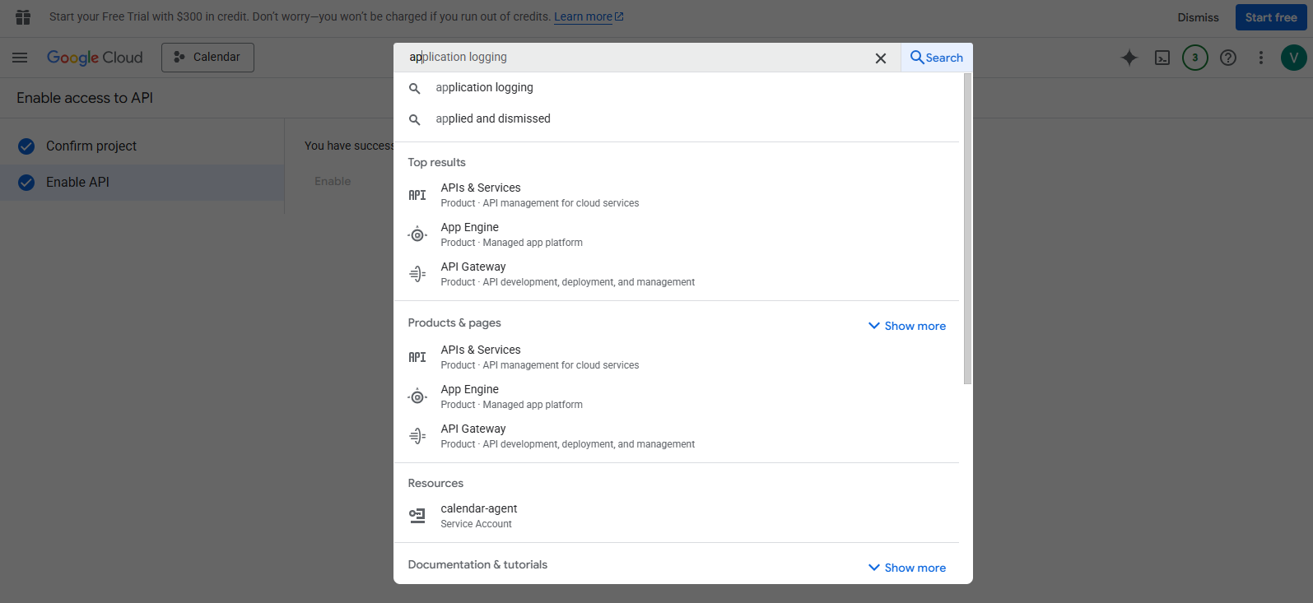
1. In Google Cloud Console, go to: Menu > Google Auth Platform > Branding.
2. If prompted, click 'Get Started'.
3. Under App Information:
- Enter your App name.
- Choose a User support email.
4. Click 'Next'.
5. Under Audience: select 'Internal' (or 'External' if your app is for public users).
6. Click 'Next'.
7. Under Contact Information: enter your email address.
8. Review the Google API Services User Data Policy, agree to it, and continue.
9. Click 'Create' to finish.

4. Create OAuth 2.0 Credentials
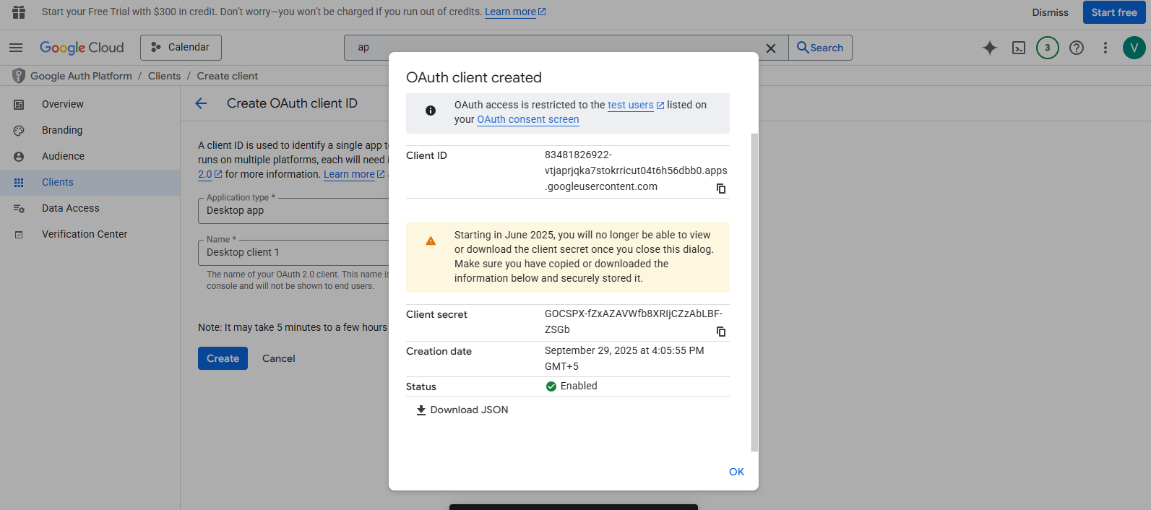
1. In Google Cloud Console, go to: Menu > Google Auth Platform > Clients.
2. Click 'Create Client'.
3. Select 'Application Type > Desktop app'.
4. Enter a name for the credential (e.g., MyApp Calendar Client).
5. Click 'Create'.
6. A new OAuth 2.0 Client ID will be created.
7. Download the JSON file.

5. Save Credentials File
1. The downloaded file will contain your client ID and client secret.
2. All data in the .json file will paste in crediential field and save the data with process detail.
3. Save it into your application working DB.

6. Next Steps
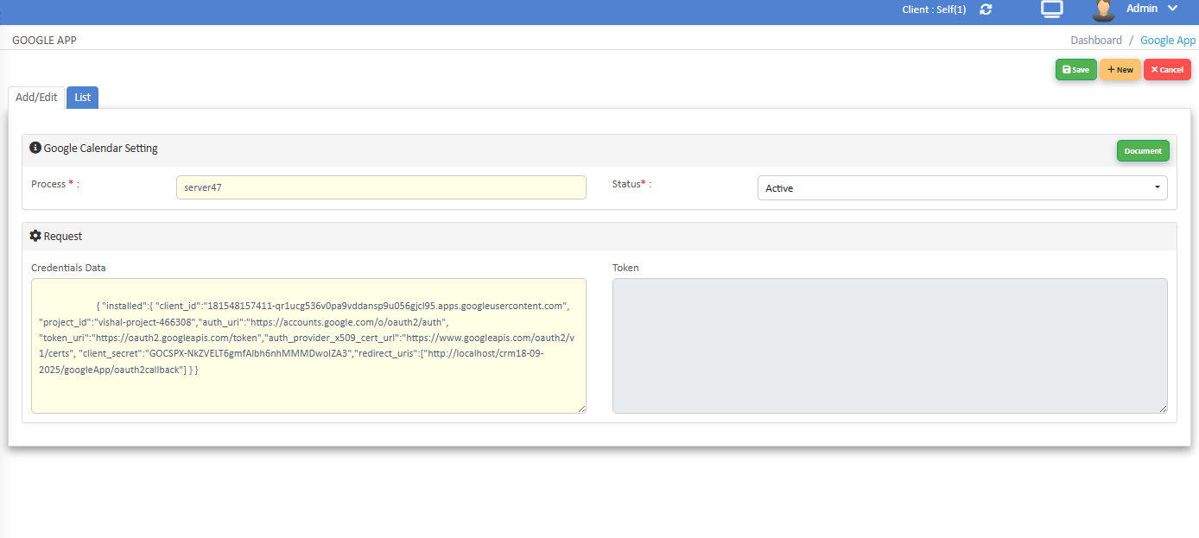

Once credentials are generated, you can use them in your application to authenticate users and access Google Calendar API. Ensure you configure the redirect URI in Google Cloud Console to match your application’s callback URL.

Last Step
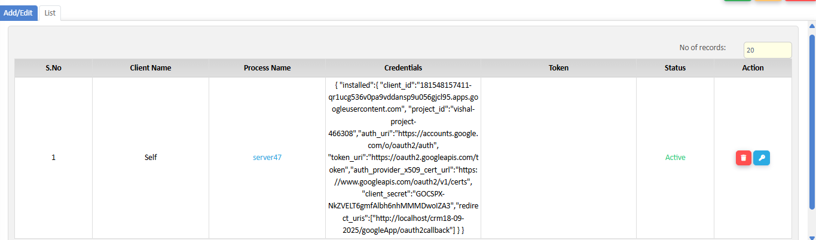
1. After save the credential you will generate token if token are generate then you will work .
2.check in table list token are generate or not if token are not found then it have wrong credientials or something wrong.

